Assessment Schedule – 2016

Calculus: Apply integration methods in solving problems (91579)

Evidence Statement
Q1 | Expected Coverage | Achievement  (u) | Merit  (r) | Excellence  (t)
(a) | 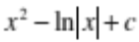 | Correct solution.  Absolute value signs not required.  c not required.
(b) | 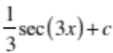 | Correct solution.  Accept 0.3, 0.33  c not required.
(c) | 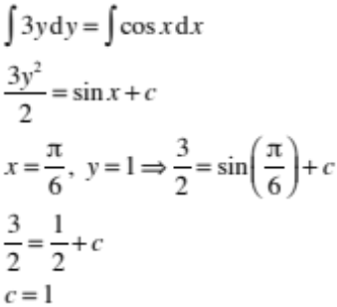  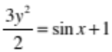  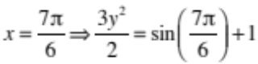  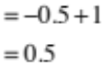  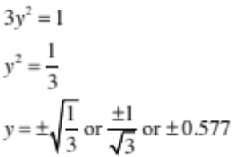 | Correct integral.  c not required. | Correct solution with correct integral.  Accept positive solution only.
(d) | Area = 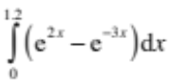  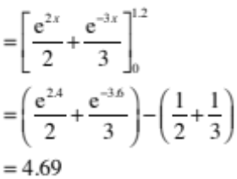 | Correct integral [inside square brackets].  c not required. | Correct solution with correct integral.  Accept any correct numerical substitution  (2nd last line)
(e) | 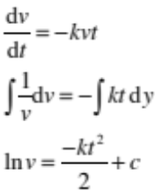  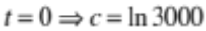  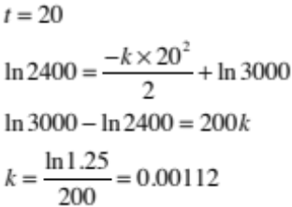  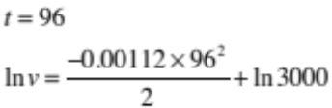  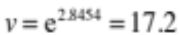mL | Correct integral. | Correct integral and correct value of k. | Correct integral and correct solution.  Accept any correct numerical substitution

NØ | N1 | N2 | A3 | A4 | M5 | M6 | E7 | E8
No response; no relevant evidence. | ONE answer demonstrating limited knowledge of integration techniques. | 1u | 2u | 3u | 1r | 2r | 1t with minor error(s). | 1t

Q2 | Expected Coverage | Achievement  (u) | Merit  (r) | Excellence  (t)
(a) | 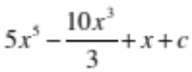 | Correct solution.
(b) | 7 | Correct solution.
(c) | 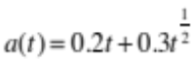  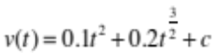  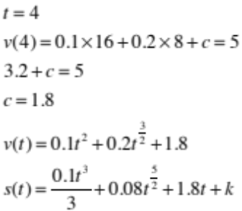  Distance travelled in first 9 seconds  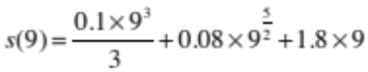  =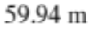 | Correct integral. | Correct solution with correct integral.  Accept 59.9, 60.  2nd last line acceptable.
(d) | 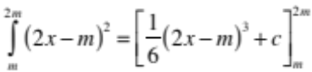  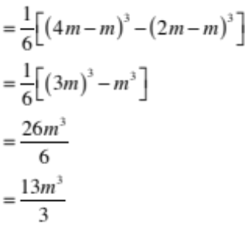  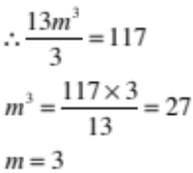 | Correct integration [inside square brackets]. | Correct solution with correct integration.
(e) | 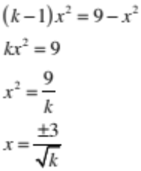  Area = 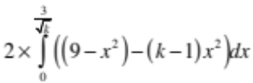  = 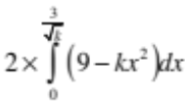  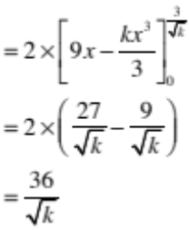  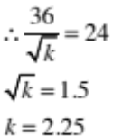 | 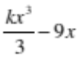 | Correct integral.  Accept 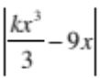 | Correct solution.  For E7:  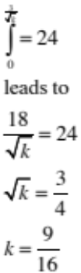  (E7)

NØ | N1 | N2 | A3 | A4 | M5 | M6 | E7 | E8
No response; no relevant evidence. | ONE answer demonstrating limited knowledge of integration techniques. | 1u | 2u | 3u | 1r | 2r | 1t with minor error(s). | 1t

Q3 | Expected Coverage | Achievement  (u) | Merit  (r) | Excellence  (t)
(a) | 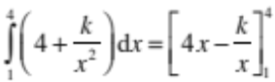  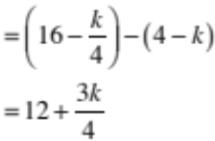  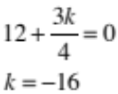 | Correct solution with correct integration.
(b) | 7.8 | Correct solution.
(c) | 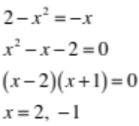  Area = 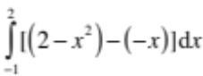  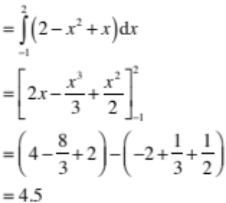 | Correct integration  [inside square brackets].  Both integrals completed separately is ok for u. | Correct solution with correct integration
(d) | 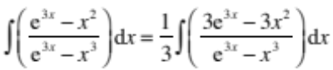  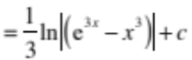 |  | Correct solution.  Absolute value signs not required.  Brackets not required.
(e) | 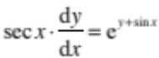  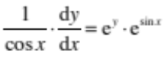  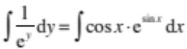  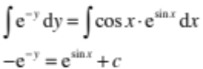  x= 0, y = –1  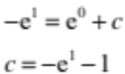  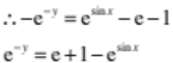  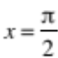  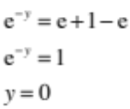 | Correct integration of 1 side. | Correct integration of both sides. | Correct solution with correct integration.  Answer may not be exactly zero if the value of c is evaluated numerically. E.g. c = –3.7183 leads to  y = –0.0611. Accept continuity.

NØ | N1 | N2 | A3 | A4 | M5 | M6 | E7 | E8
No response; no relevant evidence. | ONE answer demonstrating limited knowledge of integration techniques. | 1u | 2u | 3u | 1r | 2r | 1t with minor error(s). | 1t

Cut Scores
Not Achieved | Achievement | Achievement with Merit | Achievement with Excellence
0–6 | 7–13 | 14–19 | 20–24

